Committee Charge

Hypothesis: Residents With Greater Housing Stress May Be More Likely to Migrate

Finding: True for Owners. Owners with greater housing stress more likely to migrate.

[owner_stress_migration_percent.png]

[renter_stress_migration_percent.png]

Residential Tax Exemption

Residential tax exemption benefits those with low value homes and penalizes renters or those with high value homes.

Hypothesis: Beneficiaries of RE tax exemption have greater need than other classes.

Finding 1: More frequent reported stress among those with low market value homes than high market value homes, especially vs those in highest home value class (i.e. those who would be most affected by increased taxes under RE).

Finding 2: Much more frequent reported stress level among renters than owners.

[owner_marketvalue1_stress_percent.png]

[ownrent_stress_percent.png]

Observation: Residential Exemption will assist those in low assessment residential properties at the expense of both those in high assessment residential properties and renters. While RE will benefit the target group (lower-value home owners experiencing financial stress), it would also impact two groups: renters (who report high levels of housing stress) and high-value residences (who report lower levels of housing stress).

Means Tested Residential Exemption

Hypothesis: Means Tested Exemption Will Target Those With Greatest Housing Stress

Finding: Higher Housing Stress for Those (Approximately) Meeting Means Tested Criteria

[means_tested_stress_percent.png]

[means_tested_stress_response.png]

Senior Citizens

Hypothesis: Senior Citizens are facing more housing stress and chance of migrating away than younger residents.

Finding: False for Owners. Senior citizens may face lower levels of stress and lower predicted likelihood of migrating away than younger residents.

[own_age_stress_percent.png]

[owner_age_migration_percent.png]

------

Like the organization you’ve started. But I’m going to rewrite above to cut out all the report-context-stuff which we’re not going to be able to write well by Friday anyway. Let’s just stick very narrowly to the facts. I’m also not going to paste in any charts here but instead just put brackets where charts go and then use a script to pull in the most recent copy at that time so we get improvements in formatting til last moment. And I’m not going to format any of the above because it will be lost when I process the text

-----

What does the survey tell us:

1. About how the role of property tax stress on emigration from Lexington?

2. About how current residents would be affected by RE implementation?

3. About how current residents would be affected by MT implementation?

1.

This committee has been concerned with the whether increasing property taxes creates such financial stress that long-time, especially elderly, residents may move away from Lexington. There may be other manifestations of this stress (e.g. deferred maintenance on houses due to inability to pay both property taxes and house upkeep--Broker Round Table), and other forms of assistance may be under-utilized (e.g. tax deferment program). This committee undertook a survey of town residents with the goal of evaluating the role of property tax/financial stress on emigration plans.

Insert charts, add discussion: stress vs migration, income vs migration, income vs stress, market value vs stress, age vs migration.

Assumption: age vs migration--older residents are the ones considering leaving over increasing property taxes. Our survey suggests it is our youngest homeowners in Lexington that are most seriously considering moving away in the next decade.

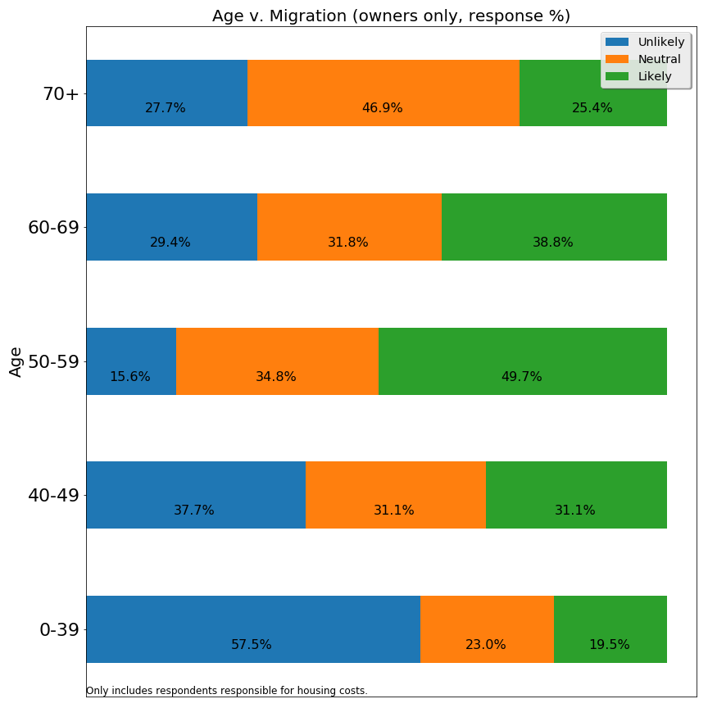

Additionally, our oldest residents do not report greater frequency of financial stress than other age cohorts.

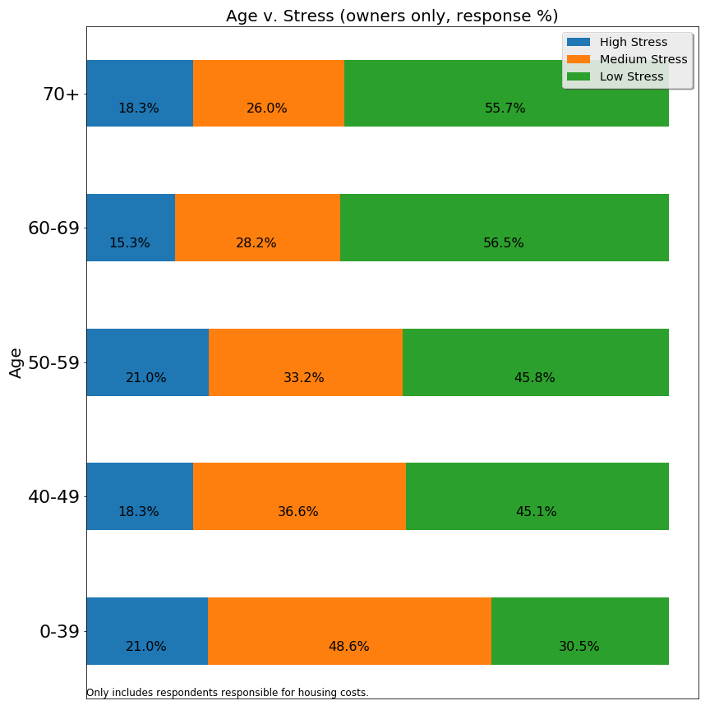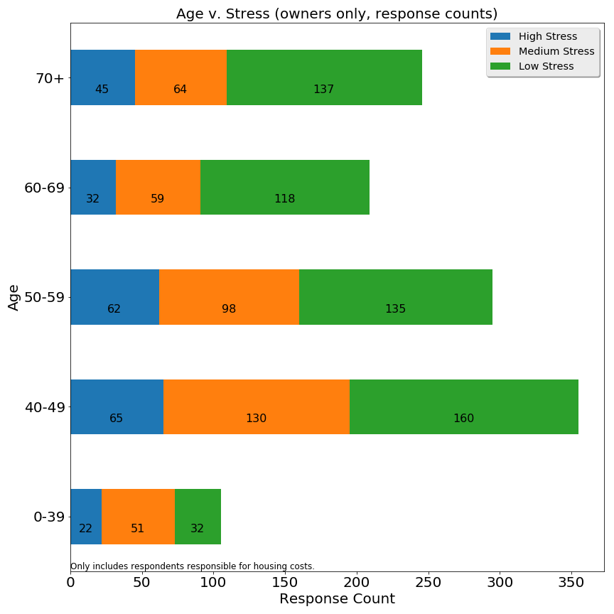

I don’t think you made a stress vs migration chart, Mark, but that might get more directly at migration these following?

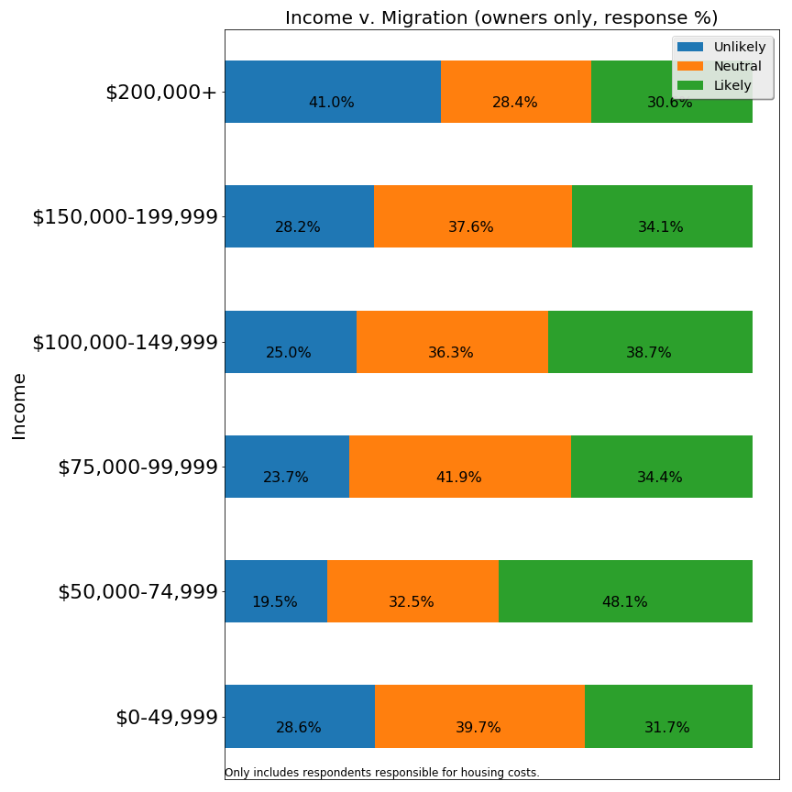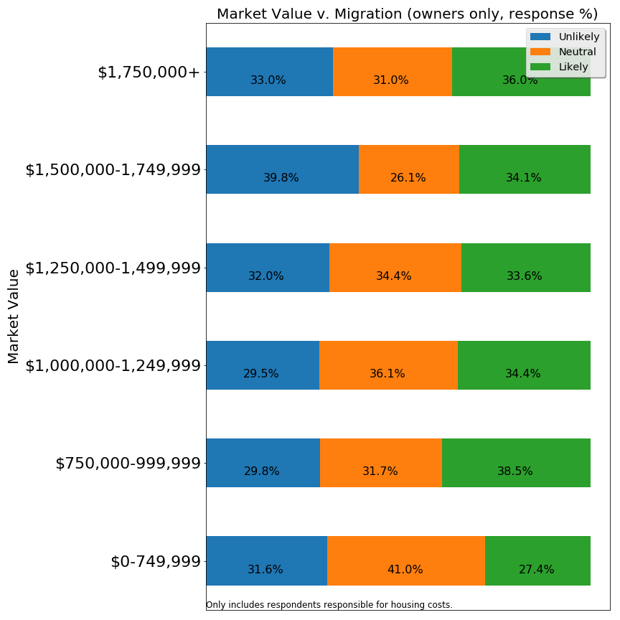

2.

The effects of RE implementation would be most extreme for homeowners with lowest bracket and highest bracket property values, and for renters. Homeowners with property values near the inflection point (approx $1.1mil) would be minimally affected.

Our sample included X people across these four categories. (insert histogram)

These groups express very different degrees of financial stress. First, we’ll address the **homeowners**.

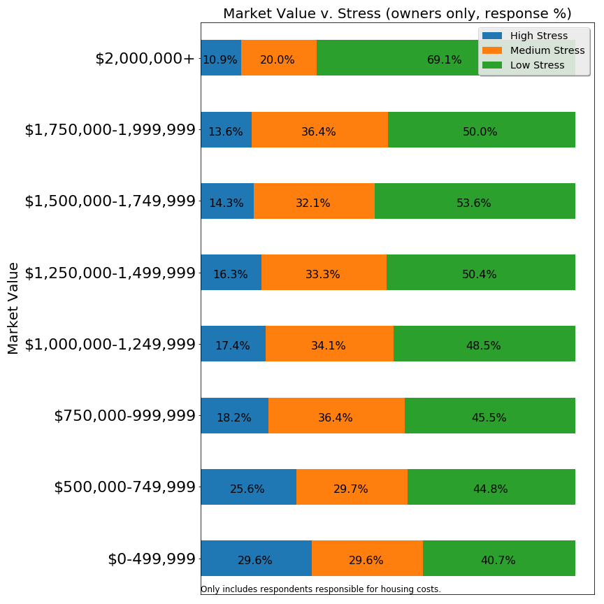

Lexington residents who own higher property value homes ($1.75million value and above) report experiencing similarly moderate to low financial stress to those who own middle range ($1.0million to $1.5million) homes. Residents who own the highest value properties ($2million+), however, report being less financially stressed than all other groups. Residents who own lower-value properties ($750K and lower) much more frequently report financial stress, especially high stress. While there are few houses valued under $500,000 in Lexington as of 2018, those homeowners would benefit most from implementation of a residential exemption, possibly enough to offset some of their financial stress. Whether property tax reduction from RE to those with properties in the $500-$750k range would be large enough to reduce their financial stress is a primary factor in evaluating RE’s potential benefit. An increased tax burden on higher value property owners, to compensate for this tax reduction at the lower end, would seem to have little effect on their overall stress load.

The picture for **renters** is dramatically different from that of homeowners. Lexington renters are a very stressed portion of our community. Over 80% are experiencing financial stress, with a full 50% of them experiencing high stress. The proportion of stressed homeowners is much lower.

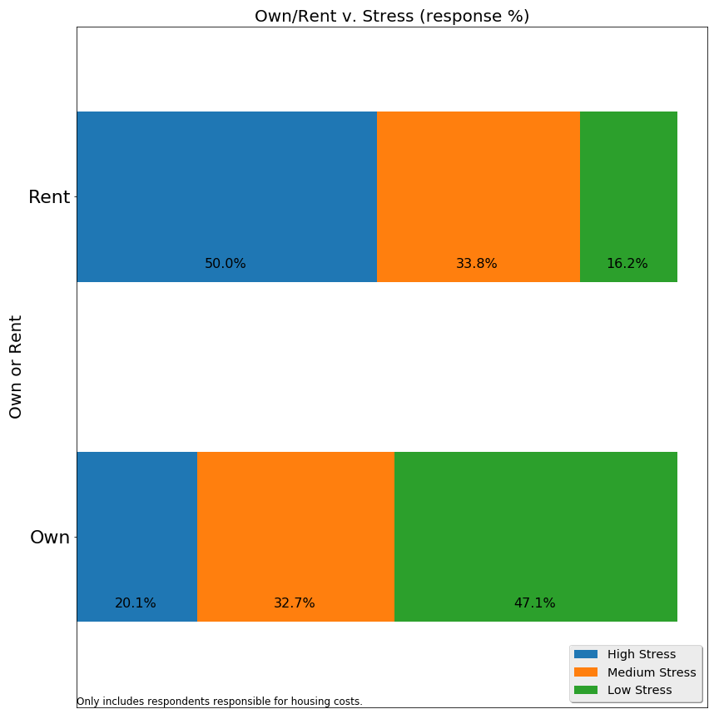

While the overall number of renters in Lexington is relatively small (and also a small number of responses to our survey), this is a group for whom an increase in property tax (***if*** passed on in the form of increased rents), would be a burden.

A question to be weighed is the role of potentially increasing hardship for renters against degree of benefit for lower value property owners.